Task for Bash Scripting.

**Basic Shell Scripts:**

1. **Output to screen**
2. **Defining Tasks**

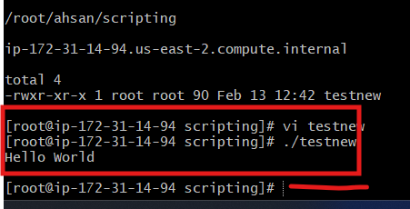

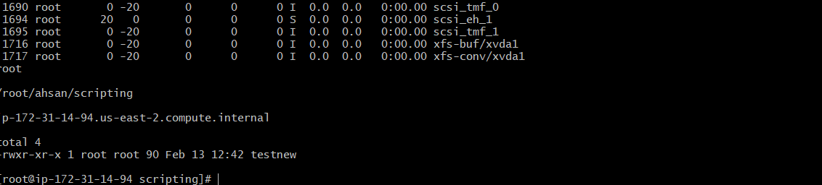

**3) Defining variables**

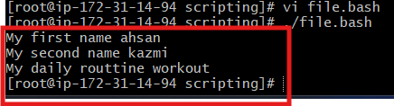

**4) Read Input**